**GENETIC ALGORITHM**

**CODE AND OUTPUTS:**

import numpy

def cal_pop_fitness(equation_inputs, pop):

    fitness = numpy.sum(pop*equation_inputs, axis=1)

    return fitness

def select_mating_pool(pop, fitness, num_parents):

    parents = numpy.empty((num_parents, pop.shape[1]))

    for parent_num in range(num_parents):

        max_fitness_idx = numpy.where(fitness == numpy.max(fitness))

        max_fitness_idx = max_fitness_idx[0][0]

        parents[parent_num, :] = pop[max_fitness_idx, :]

        fitness[max_fitness_idx] = -99999999999

    return parents

def crossover(parents, offspring_size):

    offspring = numpy.empty(offspring_size)

    crossover_point = numpy.uint8(offspring_size[1]/2)

    for k in range(offspring_size[0]):

        parent1_idx = k%parents.shape[0]

        parent2_idx = (k+1)%parents.shape[0]

        offspring[k, 0:crossover_point] = parents[parent1_idx, 0:crossover_point]

        offspring[k, crossover_point:] = parents[parent2_idx, crossover_point:]

    return offspring

def mutation(offspring_crossover):

    for idx in range(offspring_crossover.shape[0]):

        random_value = numpy.random.uniform(-1.0, 1.0, 1)

        offspring_crossover[idx, 4] = offspring_crossover[idx, 4] + random_value

    return offspring_crossover

equation_inputs = [4,-2,3.5,5,-11,-4.7]

num_weights = 6

sol_per_pop = 8

num_parents_mating = 4

pop_size = (sol_per_pop,num_weights)

new_population = numpy.random.uniform(low=-4.0, high=4.0, size=pop_size)

print(new_population)

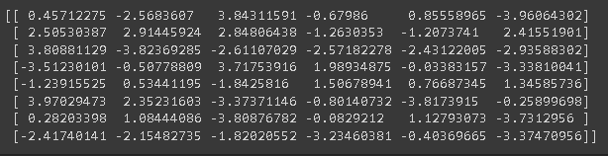

num_generations = 5

for generation in range(num_generations):

    print("Generation : ", generation)

    fitness = cal_pop_fitness(equation_inputs, new_population)

    parents = select_mating_pool(new_population, fitness,

                                      num_parents_mating)

    offspring_crossover = crossover(parents,

                                       offspring_size=(pop_size[0]-parents.shape[0], num_weights))

    offspring_mutation = mutation(offspring_crossover)

    new_population[0:parents.shape[0], :] = parents

    new_population[parents.shape[0]:, :] = offspring_mutation

    print("Best result : ", numpy.max(numpy.sum(new_population*equation_inputs, axis=1)))

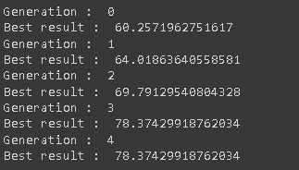

fitness = cal_pop_fitness(equation_inputs, new_population)

best_match_idx = numpy.where(fitness == numpy.max(fitness))

print("Best solution : ", new_population[best_match_idx, :])

print("Best solution fitness : ", fitness[best_match_idx])

